Collection in java

The **Collection in Java** is a framework that provides an architecture to store and manipulate the group of objects.

Java Collections can achieve all the operations that you perform on a data such as searching, sorting, insertion, manipulation, and deletion.

Interfaces 🡪 List , Set , Queue , Dequeue, SortedSet

Classes 🡪 ArrayList , LinkedList , vector , Stack

* Hashset , LinkedHashSet , treeSet
* ArrayDequeue , PriorityQueue

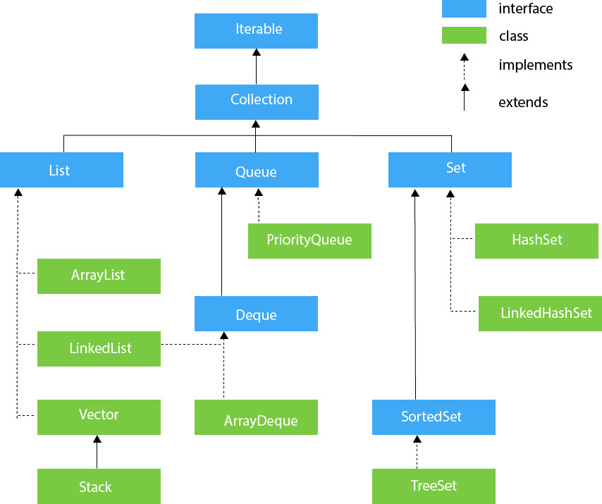

The **Exception Handling in Java** is one of the powerful mechanism to handle the runtime errors so that the normal flow of the application can be maintained.